

**NATIONAL ECONOMIC CONSULTATIVE FORUM**

**MONTHLY ECONOMIC BULLETIN**

**April 2024**

# Executive Summary

This bulletin focuses on economic developments for the month ending 30 April 2024 that include Zimbabwe Gross Domestic Product (GDP) growth updates, merchandise trade developments, exchange rate developments, inflation developments, monetary developments and stock market developments as well as world economic developments and international commodity prices.

The global economy remains remarkably resilient with growth expected to be steady but slow. According to the International Monetary Fund's (IMF) World Economic Outlook (WEO) Update for April 2024, global economic growth is projected to maintain a 2023 growth of 3.2% in 2024 and 2025. The journey has been eventful, starting with supply-chain disruptions in the aftermath of the pandemic, a Russian-initiated war on Ukraine that triggered a global energy and food crisis, followed by a globally synchronized monetary policy tightening. On the other hand, global inflation is expected to slow down from 6.8% in 2023 to 5.9% in 2024 and further decline to 4.5% in 2025.

During the month under review, the commodity prices registered an upward general trend except for crude oil, cotton and soyabeans. This was largely due to geopolitical tensions such as Russia-Ukraine war and the Gaza war which disrupted supply chains as well as the El Nino induced drought.

Zimbabwe’s growth rate in 2024 is expected to be lower than 2023 growth due to the effects of the El Nino induced drought, the impact of structural bottlenecks and lower commodity prices. El-Nino-induced drought affected most rain-fed crops and is intensifying electricity supply shortages. In terms of outlook, the IMF in its April 2024 WEO update, anticipate Zimbabwe’s economic growth to drop from 5.3% realised in 2023 to 3.2% in 2024 and 2025.

The Reserve Bank of Zimbabwe (RBZ) introduced a new structured currency called Zimbabwe Gold (ZiG) which is fully backed by forex reserves, gold and other precious minerals. However, during the month under review, the ZiG depreciated against all major currencies on the official market mainly due to conversion from Zim dollar to ZiG. On the parallel market, the ZiG was trading around USD1: ZiG21 against an official exchange rate of USD1: ZiG13.43 translating to a premium of 56.37% as at 30 April 2024. Meanwhile, on month-on-month basis, the United States Dollar appreciated against the British Pound and the Euro but depreciated against the South African Rand.

During the month under review, MoM inflation stood at 2.9% down from 4.9% recorded in March 2024 while all items monthly inflation rate recorded a marginal increase from 97.14% in March 2024 to 100% in April 2024. The main drivers being food, non-alcoholic beverages, housing, water, electricity, gas and other fuels.

Meanwhile, during the reporting period data on broad money supply (M3) had not been published by the RBZ. Thus, analysis relied on data available as at March 2024. In this regard, M3 stood at ZiG23.68 million in March 2024 reflecting a 45.70% increase from 16.25 million in February 2024. The money stock comprised foreign currency deposits, 86.80% local currency deposits, 13.17%, and the local currency in circulation, 0.03%. During the period under review, the bank policy rate was pegged at 20% per annum consistent with the 2024 monetary policy framework.

Similarly, by the time of compiling the report, the Zimbabwe National Statistical Agency (ZimStat) had not published data on merchandise trade for April 2024, therefore, the analysis was mainly based on March 2024 data. In this regard, the country’s trade deficit stood at US$184.3 million during the month under review, higher than US$81.4 million recorded in the previous month. The country’s deficit narrowed from US$229.20 million in March 2023 to US$184.3 million in March 2024

Regarding stock market developments, both the Zimbabwe Stock Exchange (ZSE) and Victoria Falls Stock Exchange recorded a bearish trend with All-Share Index growth of -71.74% and -1.44 on MoM, respectively. This is mainly attributed to the transition to the new structured currency.

Table of Contents

Executive Summary i

1.0 World Economic Developments 1

1.1 World Output 1

1.2 Global Inflation Developments 2

2.0 International Commodity Prices 2

3.0 Zimbabwe GDP Growth Update 3

4.0 Merchandise Trade Developments 4

5.0 Exchange Rate Developments 4

5.1 Zimbabwean Dollar Exchange Rate Developments 4

5.2 Cross Rate Developments 5

6.0 Inflation Developments 6

7.0 Monetary Developments 7

7.1 Money Supply 7

7.2 Interest Rates 7

8.0 Stock Market Developments 8

8.1 Zimbabwe Stock Exchange 8

8.2 Victoria Falls Stock Exchange 8

9.0 Recommendations 9

10.0 References 10

**List of Tables**

Table 1: Global Economic Growth Developments 1

Table 2: Commodity Price Movements – Month Ending 30 April 2024 3

Table 3: ZWL$ Exchange Rate Movements – Month Ending 30 April 2024 5

Table 4: USD Exchange Rate Movements – Month Ended 30 April 2024 6

Table 5: Inflation by Sector April 2024 7

Table 6: Zimbabwe Stock Exchange Movements 8

Table 7: Victoria Falls Stock Exchange Movements 8

**List of Figures**

Figure 1: Global Inflation Prospects 2

Figure 2: Zimbabwe Economic Growth Prospects 3

Figure 3: Merchandise Trade Developments 4

Figure 4: Exchange Rate Developments 5

Figure 5: Month-on-Month Inflation Outturn 6

# 1.0 World Economic Developments

## **1.1 World Output**

1.1.1 According to the International Monetary Fund (IMF) World Economic Outlook (WEO) Update for April 2024, the global economy remains remarkably resilient with growth expected to be steady but slow. The global economy is expected to maintain a growth of 3.2% from 2023, 2024 and 2025 on the back of recovery of supply-chain interruptions in the aftermath of the pandemic, Russian-initiated war on Ukraine that triggered a worldwide oil and food crisis, followed by a globally synchronized monetary policy tightening.

1.1.2 Table 1 summarizes global economic growth developments and prospects for selected regions and countries.

Table 1: Global Economic Growth Developments

|  |  |  |  |  |  |  |
| --- | --- | --- | --- | --- | --- | --- |
|  | **2023** | | **2024** | | **2025** | |
| Est. (Jan24 Report) | Act. (Apr24 Report) | Est. (Jan24 Report) | Est. (Apr24 Report) | Est. (Jan24 report) | Est. (Apr24 Report) |
| **World Output** | **3.1** | **3.2** | **3.1** | **3.2** | **3.2** | **3.2** |
| **Advanced Economies** | **1.6** | **1.6** | **1.5** | **1.7** | **1.8** | **1.8** |
| United States | 2.5 | 2.5 | 2.1 | 2.7 | 1.7 | 1.9 |
| Euro-Area | 0.5 | 0.4 | 0.9 | 0.8 | 1.7 | 1.5 |
| **Emerging Markets & Developing Economies** | **4.1** | **4.3** | **4.1** | **4.2** | **4.2** | **4.2** |
| China | 5.2 | 5.2 | 4.6 | 4.6 | 4.1 | 4.1 |
| India | 6.7 | 7.8 | 6.5 | 6.8 | 6.5 | 6.5 |
| **Sub-Saharan Africa** | **3.3** | **3.4** | **3.8** | **3.8** | **4.1** | **4** |
| Nigeria | 2.8 | 4.2 | 3 | 3.3 | 3.1 | 3 |
| South Africa | 0.6 | 0.6 | 1 | 0.9 | 1.3 | 1.2 |

*Source: IMF World Economic Outlook Update (January and April 2024)*

1.1.3 Growth in Advanced Economies is likely to increase to 1.7% in 2024 from 1.6% in 2023 and rebound slightly to 1.8% in 2025 owing to improvements in both the United States and the European economies. Growth in the Euro-Area is anticipated to increase to 0.8% in 2024 from 0.4% in 2023 before further increasing to 1.5% in 2025 while the United States economy is expected to grow by 2.7% in 2024 from a growth of 2.5% in 2023 then fall to 1.9% in 2025.

Zimbabwe's economic prospects are influenced by global economic movements such as commodity prices, the Ukraine and Gaza conflicts, and restrictive monetary policies.

1.1.4 The growth of Emerging Markets and Developing Economies has been reviewed upwards to 4.3% in 2023 from 4.1%. In terms of outlook, growth is expected to fall to 4.2% and maintain that growth in 2025. The is mainly attributed to slow down in China’s growth from 5.2% in 2023 to 4.6% in 2024 and further decline to 4.1% in 2025. In the same vein, India’s growth is expected to decline from 7.8% in 2023 to 6.8% in 2024 and 6.5% in 2025.

1.1.5 The Sub-Saharan Africa (SSA) is expected to pick up from 3.4% in 2023 to 3.8% in 2024 and further to 4% in 2025. This is on the back of expected increased economic activity in Nigeria and South Africa.

## **1.2 Global Inflation Developments**

1.2.1 Global inflation is expected to slow down from 6.8% in 2023 to 5.9% in 2024 and further decline to 4.5% in 2025, according to the IMF WEO Update for April 2024, as shown in Figure 1.

Figure 1: Global Inflation Prospects

The global inflation prospects suggest tightening monetary policy by central banks.

*Source: IMF World Economic Outlook Updates (January and April 2024)*

## **2.0 International Commodity Prices**

2.1 During the month under review, the commodity prices registered an upward general trend. This was largely due to geopolitical tensions such as Russia-Ukraine war, Gazar war which disrupted supply chains and El Nino induced drought.

2.2 On a year-to-date basis (YtD), gold gained 12.48% and 15.16% on year on year (YoY) basis while copper gained 16.86% YtD and 17.95% on YoY. Nickel gained 20.14% and lost 20.54% YtD and YoY, respectively while Aluminium gained 13.46% on YtD and 9.80% on YoY. *This trend, particularly for gold, copper, and aluminium, is positive and bodes well for the country's mining sector and future growth.*

2.3 On agricultural commodities, cotton lost by 7.91% and 2.93% on YtD and YoY, respectively, whilst wheat also lost 0.33% on YtD and 2.66% YoY. Corn lost by 2.56% YtD and 29.76% YoY. Soyabeans lost by 7.05% on YtD and 20.66% on YoY. *Cotton, corn, soyabeans and wheat prices prospects are discouraging for the country’s agricultural sector growth prospects.*

2.4 On a monthly basis, natural gas, aluminium, copper, nickel, gold, corn, and wheat recorded gains while Crude oil (Brent), cotton and soyabeans recorded losses as Shown in Table 2.

Table 2: Commodity Price Movements – Month Ending 30 April 2024

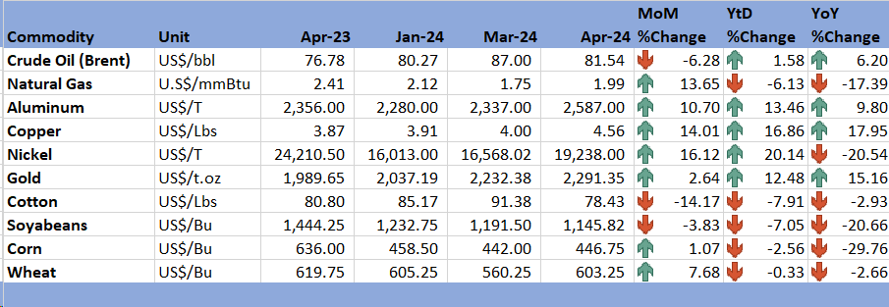

*Source: Trading Economics (2024)*

# 3.0 Zimbabwe GDP Growth Update

3.1 According to the 2024 Monetary Policy Statement, Zimbabwe's GDP is anticipated to increase by 3.5% in 2024, higher than the IMF's WEO April 2024 update projection of 3.2% as shown in Figure 2.

Figure 2: Zimbabwe Economic Growth Prospects

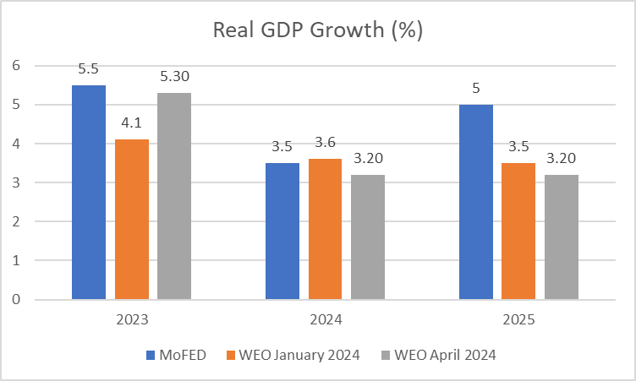

*Source: MoFED&IP (2024); IMF WEO Updates (January and April 2024)*

3.2 The country’s growth rate in 2024 is expected to be lower than 2023 growth due to the effects of the El Nino induced drought, the impact of structural bottlenecks and lower agricultural commodity prices. El-Nino-induced drought affected most rain-fed crops and is intensifying electricity supply shortages.

3.3 In terms of outlook, the April IMF WEO Update projects Zimbabwe to grow by 3.2% lower the 3.5% initially projected in the Jan Update.

# 4.0 Merchandise Trade Developments

4.1 By the time of compiling this report, ZimStat had not published the merchandise trade data for the month of April 2024, thus the analysis relied on the available data as of March 2024. In this regard, the country’s trade deficit stood at US$184.3 million during the month under review, higher than US$81.4 million recorded in the previous month. The country’s deficit narrowed from US$229.20 million in March 2023 to US$184.3 million in March 2024 as shown in Figure 3.

**Figure 3: Merchandise Trade Developments**

*Source: ZimStat (2024)*

4.2 The country's primary export commodities, including gold, PGMs, tobacco, and industrial diamonds, were the leading export commodities, contributing 23.6%, 26.6%, 13.9%, and 10.8% respectively. On the other hand, the country's imports in March 2024 primarily consisted of diesel, maize, leaded petrol, and crude soya bean oil, which represented 10.5%, 5.9%, 5.1%, and 2.5% of the total imports, respectively.

# 5.0 Exchange Rate Developments

## **5.1 Zimbabwean Dollar Exchange Rate Developments**

5.1.1 The Reserve Bank of Zimbabwe (RBZ) introduced a structured currency called Zimbabwe Gold (ZiG) on 5th of April 2024. However, during the month under review, the ZiG depreciated against all major currencies, as shown by Table 3. On MoM basis, the ZiG depreciated by about 52.15% against the USD. On an YtD and YoY basis, the ZiG lost by 230.54% and 3513.88%, respectively against the USD. *The depreciation of the ZiG on MoM, YtD and YoY basis on the official market is mainly due to the conversion from the Zim dollar to the ZiG.*

Table 3: ZWL$ Exchange Rate Movements – Month Ending 30 April 2024

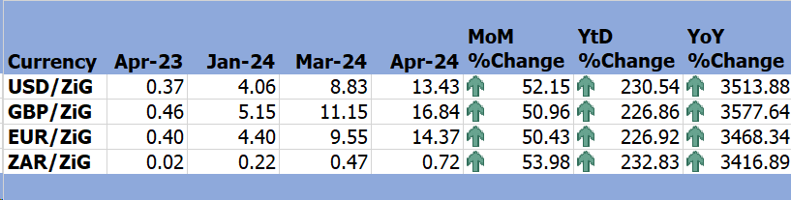

*Source: RBZ (2024)*

5.1.2 During the period under review, the market exchange rate premium remained high inhibiting the opportunity for convergence between the official and the parallel market exchange rates as indicated in Figure 4.

**Figure 4: Exchange Rate Developments**

*Source: RBZ (2024) and Harare Streets*

## **5.2 Cross Rate Developments**

5.2.1 On MoM basis, the USD depreciated by 1.23% against the South African Rand (ZAR) and gained against the British Pound and EUR, by 0.79% and 1.15% respectively as shown in Table 4. *If the appreciation of the ZAR against the USD is maintained going forward, this has the effect of discouraging imports from South Africa and promoting local production and exports.*

Table 4: USD Exchange Rate Movements – Month Ended 30 April 2024

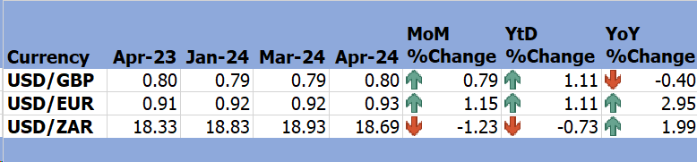

*Source: RBZ (2024)*

5.2.2 Meanwhile, the USD weakened by 0.73% on YtD basis and gained by 1.99% on YoY basis against the ZAR as the economy was still recovering from the COVID-19 pandemic effects. *This trend of the ZAR promotes competitiveness of Zimbabwean goods in the South African market.*

# 6.0 Inflation Developments

6.1 During the month under review, MoM inflation stood at 2.9% down from 4.9% recorded in the previous month, see Figure 5.

6.2 On the other hand, all items monthly inflation rate recorded an increase from 97.14% in March 2024 to 100% in April 2024 (see Table 5). The main drivers being food and non-alcoholic beverages and housing, water, electricity, gas and other fuels.

**Figure 5: Month-on-Month Inflation Outturn**

*Source: ZimStat (2024)*

6.5 Table 5 shows the main drivers of inflation in the month of April 2024.

Table 5: Inflation by Sector April 2024

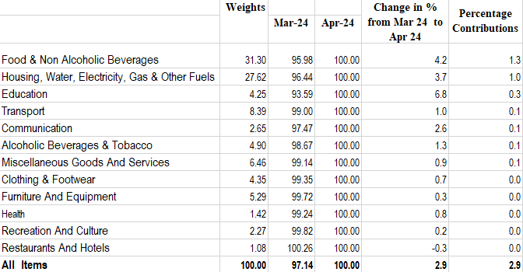

*Source: ZimStat (2024)*

# Monetary Developments

## **7.1 Money Supply**

7.1.1 At the time of compiling the report, the RBZ had not published data on M3 for April 2024, thus analysis is based on data available up to March 2024. M3 stood at ZiG23.68 million in March 2024 reflecting a 45.70% increase from 16.25 million in February 2024.

7.1.2 The money stock comprised foreign currency deposits, 86.80% local currency deposits, 13.17%, and the local currency in circulation, 0.03%.

## **7.2 Interest Rates**

7.2.1 The reporting of interest rates is based on the 2024 Monetary Policy Statement. In this regard, during the period under review, the bank policy rate was pegged at 20% per annum consistent with the 2024 monetary policy framework.

7.2.2 The overnight accommodation interest rate has been fixed at 5% above the Bank policy rate, while the bank deposit facility rate is 7.5% below the Bank policy rate.

7.2.3 Savings and time deposits interest rates on ZiG are set at 9% and 7.5% lower than the Bank deposit facility rate of 12.5%, respectively. While interest rates on FCA deposits remain unchanged at 1% and 2.5% for savings and time deposits, respectively.

# 8.0 Stock Market Developments

## **8.1 Zimbabwe Stock Exchange**

8.1.1 During the period under review, the Zimbabwe Stock Exchange (ZSE) recoded a bearish trend. The All share index lost by 71.74% and 53.95% on MoM and YtD, respectively, while on YoY it gained 496.56%. Similarly, the Top 10 index lost 39.36% and 0.39% on MoM and YtD basis, respectively while on a YoY it gained 915.28% (see Table 7).

Table 6: Zimbabwe Stock Exchange Movements

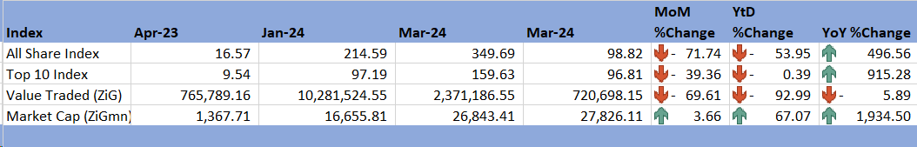

*Source: ZSE (2024)*

8.1.2 Market Capitalisation in April 2024 was ZiG27826.11 million reflecting a 3.66% increase from the ZiG26843.41 million in March 2024. On a YtD and YoY basis, market capitalization added 67.07% and 1934.5%, respectively as shown in Table 7.

## **8.2 Victoria Falls Stock Exchange**

8.2.1 During the month of April 2024, the Victoria Falls Stock Exchange (VFEX) recorded a bearish trend. On MoM basis, the All Share Index lost by 1.44%, while Valued Traded decreased by 98.85% and market capitalization lost by 1.65% as shown in Table 8.

8.2.3 On a YtD basis, the All Share Index, Value Traded and market capitalisation registered negative trends. On YoY basis, the All Share Index gained by 15% while the value traded lost by 96.21% and market capitalisation lost by 5.61%.

Table 7: Victoria Falls Stock Exchange Movements

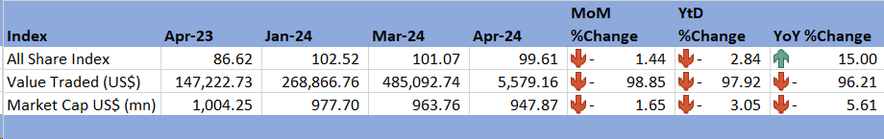

*Source: VFEX (2024)*

# 9.0 Recommendations

9.1 The following recommendations are being proposed:

9.1.1 **Diversify Export Markets:** Given the expected steady but slow global economic growth, there is need to diversify the country’s export markets to mitigate risks associated with economic slowdowns in major trading partners. The country can establish trade agreements with emerging markets, particularly in Asia and other fast-growing regions.

9.1.2 **Enhance Competitiveness:** Advanced economies and major emerging markets are projected to grow, albeit modestly. Zimbabwe should capitalize on this by improving its product competitiveness. Strategies such as investing in technology and infrastructure to enhance productivity and reduce production costs are most welcome.

9.1.3 **Strengthen Inflation Control Measures**: Global inflation is projected to decrease, which could influence local inflation trends. In this regard, the country should implement policies to stabilize prices, such as improving supply chains for essential goods and tightening monetary policy when necessary.

9.1.4 **Leverage Mining Sector Growth:** Positive trends in gold, copper, and aluminium prices can bolster the mining sector. Therefore, the country should aim to attract foreign investment in mining through favourable policies and ensure the efficient and environmentally responsible extraction of minerals.

9.1.5 **Support Agricultural Sector:** Negative trends in cotton, corn, soybeans, and wheat prices pose challenges. The country should provide subsidies, introduce drought-resistant crop varieties, and invest in irrigation infrastructure to mitigate the effects of price volatility and El Nino-induced droughts.

9.1.6 **Reduce Trade Deficit:** A high trade deficit can deplete foreign reserves and weaken the local currency. Therefore, the country should promote export-oriented industries and reduce import dependence by enhancing local production capabilities and competitiveness.

9.1.7 **Expand Export Product Base:** Reliance on a few primary export commodities increases vulnerability. Thus, the country should diversify exports by developing value-added products and exploring new markets.

9.1.8 **Promote Confidence in ZiG:** The depreciation of the ZiG on the parallel market indicates a lack of confidence. As at 30 April 2024, the official exchange rate was at USD1: ZiGL$13.43 while the parallel market rate was at around USD1: ZiG$21.00 translating to a premium of 56.37%. Authorities should ensure transparency and stability in monetary policy and bolster the credibility of the new currency through sound economic policies. Building adequate reserves to back the local currency is critical going forward.

9.1.9 **Control Food and Fuel Prices:** Food and fuel prices are major drivers of inflation. Therefore, there is need to subsidize critical sectors, improve supply chain logistics, and invest in alternative energy sources to stabilize fuel prices.

# 10.0 References

IMF. (2024). *World Economic Outlook Update, April 2024.* International Monetary Fund.

IMF. (2024). *World Economic Outlook Update, January 2024.* International Monetary Fund.

MOFEDIP. (2023). *The 2024 National Budget Statement.* Ministry of Finance, Economic Development and Investment Promotion.

RBZ. (2024). *2024 Monetary Policy Statement.* Reserve Bank of Zimbabwe.

RBZ. (2024). *Exchange Rates*. Retrieved from Reserve Bank of Zimbabwe: https://www.rbz.co.zw/index.php/research/markets/exchange-rates

Trading Economics. (2024). *Commodities*. Retrieved from Trading Economics: https://tradingeconomics.com/commodities

VFEX. (2024). *VFEX Main Dashboard* . Retrieved from Victoria Falls Stock Exchange: https://www.vfex.exchange/

ZimStat. (2024). *Inflation Rates*. Retrieved from Zimbabwe National Statistical Agency: https://www.zimstat.co.zw/

ZimStat. (2024). *Merchandise Trade Statisitics* . Retrieved from Zimbabwe National Statistical Agency: https://www.zimstat.co.zw/

ZSE. (2024). *ZSE Main Dashboard*. Retrieved from Zimbabwe Stock Exchange: https://www.zse.co.zw/

**NECF Secretariat, 2024**